Loudspeakers Line Isolator System

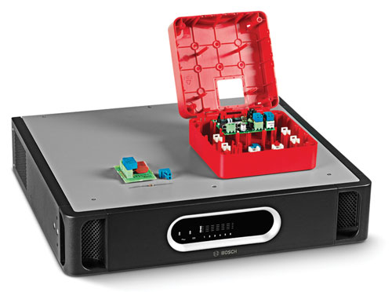
en Architect’s &
Engineer’s
Specifications

About this Document

Purpose
When preparing a specification, tender or quotation for a Bosch Loudspeakers Line Isolator System, it may be necessary to supply a detailed functional description of all equipment supplied. The Architect’s and Engineer’s Specifications presented in this publication are intended to be used for these purposes, and may be copied and/or reproduced as required.

Scope
The Bosch Loudspeakers Line Isolator System should be used in combination with the Praesideo Emergency Sound System or the Plena Voice Alarm System. This Architect’s and Engineer’s Specifications only contains the functional description specific for the Bosch Loudspeakers Line Isolator System.

Audience
These Architect’s and Engineer’s Specifications meet the needs of contractors, consultants and other professionals involved in project management, or in designing, specifying and procuring public address/ voice alarm systems.

Copyright
Bosch Security Systems BV, Eindhoven, owns the copyright of these specifications but authorized professional persons and organizations for the purpose of compiling tenders, specification proposals and related documentation in support of their sales and project management activities may reproduce them in whole or in part.

Document Format
The Architect’s and Engineer’s Specifications are available as a digital document in the Word format (.doc). All references to pages, figures, tables, etc. in this digital document contain hyperlinks to the referenced location.

Table of contents

1 Introduction 4
2 Scope of Specification 4
3 System summary 4
3.1 System overview 4
3.2 System functions 4
3.3 Approvals and compliance 4
3.4 System compatibility 5
3.5 System configuration 5
3.6 System installation and interconnection 6
3.7 System operation 6
3.8 First-line system maintenance 6
4 Technical Specifications 7
4.1 Master Unit 7
4.2 Isolator Board 8
4.3 End-of-line resistor 8
4.4 DC Blocking Board 8

Introduction
The Loudspeakers Line Isolator System shall be a lower cost alternative for ensuring functionality in public address and voice alarm systems in case of fire or other calamities. The main purpose of the system shall be to prevent loss of audio function as a result of loudspeaker line faults.

It shall largely eliminate the need for expensive E30 cabling by making use of the loop-wiring method. The system shall be fully supervised and shall be configurable to suit the public address/voice alarm installation.

The applications shall include:
- Public address systems that cover large zones. i.e. more than 25 loudspeakers per zone.
- Voice alarm: Locations that have several rooms in the same fire zone.

Scope of Specification
This specification shall cover the provision, installation and maintenance of the Loudspeakers Line Isolator System.

System summary

System overview
The Loudspeakers Line Isolator System shall comprise of a Master Unit, Isolator Boards, and DC Blocking Boards.

The zone outputs of the public address/voice alarm system shall be connected to the Master Unit, which shall manage a total of six 500-watt loudspeaker loops. The Isolator Boards shall be daisy-chained in the loudspeaker loop and shall distribute audio from the public address/voice alarm system to the loudspeakers.

The status of each loop shall be indicated by LEDs on the front panel of the Master Unit. The front panel shall also have LEDs to indicate the status of the mains supply and back-up battery power supply. All fault indicators on the front panel shall be linked to fault relays on the rear panel of the Master Unit.
The rear panel shall contain the interconnections, voltage selector, mains power switch, and DIP switches for setup and test purposes.

The Isolator Boards shall have two 100 volt audio connectors for connecting to both sides of the loudspeaker loop and a third 100 volt audio connector for creating a tap-off for one or more loudspeakers. Jumper settings shall be provided to set the permissible loudspeaker power level (10, 36, 100 watt or 10 watt with 20 kHz pilot tone filter), and other supervision settings.

The Isolator Board shall have a Test/fault LED. The Isolator Board shall be mounted in a red IP30-rated housing. The LED shall be visible when the board is mounted in the housing, allowing for easy fault-finding in the system.

The DC Blocking Board shall block DC and provide overload protection by means of current limiting. It shall have the same connections as the Isolator Board, which shall allow for quick and convenient connection of the loudspeaker loop and tap-off connections (10 watt loudspeaker load).

System functions
The Master Unit shall monitor the loudspeaker loop for loop faults and shall display this on the front panel.

The main function of the Isolator Boards shall be to:
- detect and isolate short circuits in the adjacent section.
- detect and isolate open circuits, short circuits, and overloads on a tap-off.

Approvals and compliance
The Loudspeakers Line Isolator System shall comply with all applicable regulations and standards for this type of equipment, and shall especially have the following approvals and compliance:

Approvals
Safety | acc. to EN 60065
Emission | acc. to EN 55103-1
Immunity | acc. to EN 55103-2, and EN 50130-4
Maritime | acc. to EN 60945
Evacuation | acc. to EN 54-16

Compliance
Compliant for use as described in | NEN2575, VDE0833, and BS5839
Evacuation | acc. to EN 60849

In addition, the system shall comply with all applicable international, national and local regulations for the design, construction and installation of electrical equipment.

System compatibility
The Loudspeakers Line Isolator System shall be tested with the following products and product lines:

Product lines:
- Praesideo Emergency Sound System
- Plena (VAS) Voice Alarm System
Praesideo Amplifiers:
- Power Amplifiers: PRS-1P500, PRS-2P250 and PRS-4P125
- Basic Amplifiers: PRS-1B500, PRS-2B250 and PRS-4B125
Plena Voice Alarm System units:
- Plena Voice Alarm Controller: LBB1990/00
- Plena Voice Alarm Router: LBB1992/00
- Plena Power Amplifiers: LBB1930/20, LBB1935/20, and LBB1938/20

The Loudspeakers Line Isolator System shall be compatible for use with the Praesideo family
loudspeaker supervision products (LBB4440/00, LBB4441/00, LBB4442/00, and LBB4443/00).

System configuration
It shall be possible to use the following installation options:

Installation option 1: One Isolator Board for each loudspeaker:
A maximum of 50 Isolator Boards shall be installed in each loudspeaker loop for this option.

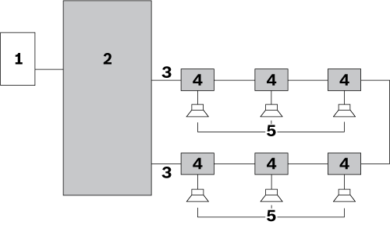

Installation option 2: Branch of loudspeakers connected to an Isolator Board:

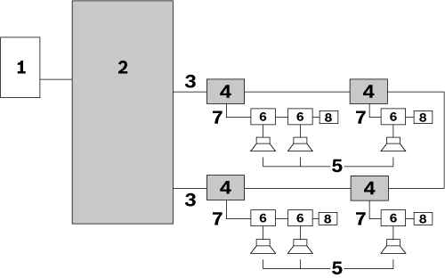

Installation option 3: Loudspeakers connected between Isolator Boards:

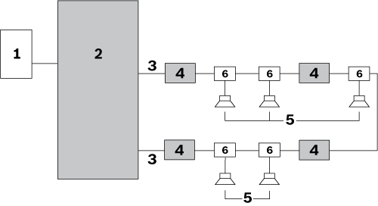

Combined installation options:
It shall be possible to combine installation options:

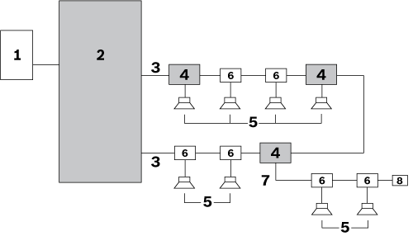

No. | Item
1 | Zone output of public address/voice alarm system
2 | Master Unit
3 | Loudspeaker loop (one loop shown)
4 | Isolator Board
5 | Loudspeaker
6 | DC Blocking Board

System installation and interconnection
The Master Unit(s) shall be built into 19” rack(s).

Installation of the system shall be based on the loop wiring method. All loudspeakers shall be connected to the system by using an Isolator Board, a DC Blocking Board, or a DC blocking capacitor.

The maximum wiring gauge of cables used for the loudspeaker loop shall be 2.5 mm². The maximum cable length of each loudspeaker loop shall be 1000 m (3281 ft).

The total maximum cable capacitance of each loop shall be 600 nF, including the tap-off cable capacitance.
The total maximum cable impedance in each loop shall be 24 ohms.

The maximum cable length from a tap-off to a loudspeaker shall be 50 m (164 ft), independent of the
loop length. The maximum permissible load on a DC Blocking Board shall be 20 watts.

System operation
The Loudspeakers Line Isolator System shall be fully supervised. There shall be no operator controls on the front or rear panels of the Master Unit.

The user interface on the front panel of the Master Unit shall consist of LEDs that indicate the following conditions:
- Walk Test mode
- Fault
- Loop initialization
- Loop OK

The status of the mains supply and back‑up battery power supply shall be also indicated on the Master Unit.

The Master Unit, Isolator Boards, and DC Blocking Boards shall be able to operate at a maximum operating temperature of 55 °C.

The system shall check for fault conditions in the main loudspeaker loop.

First-line system maintenance
The system design shall permit fast and effective fault location and correction by local personnel. This shall be supported by a built-in Walk Test mode. Spare parts and instructions shall be provided.

Technical Specifications
The device shall have the following Technical Specifications:

Master Unit

Electrical

Mains power supply
Voltage | 115 / 230 VAC, ±10%, 50/60 Hz
Fuse rating | T6.3 A, 250 V
Inrush current | Time: < 10 ms; ≤ 30 A
Max power consumption | 150 W

Battery power supply
Voltage | 18 – 56 VDC nominal 24 or 48 VDC
Backup fault detection level | 21 ± 1 VDC
Max backup power current | 4.5 A

Hardware Interfaces
100 V audio I/O  (loop 1-6) | Pluggable screw connector
Fault output (loop 1-6) | Floating contacts 24 V, 1 A
Fault relays except general fault relay | - OK state is normally de-energized  - NO is open
General fault relay | - OK state is Failsafe, normally energized  - NC is open (failsafe)

Performance
Max. number of Isolator Boards in loop | 50
Power handling capacity per loop | 500 W
Frequency range | 50 Hz – 20 kHz

Battery power consumption 24 V

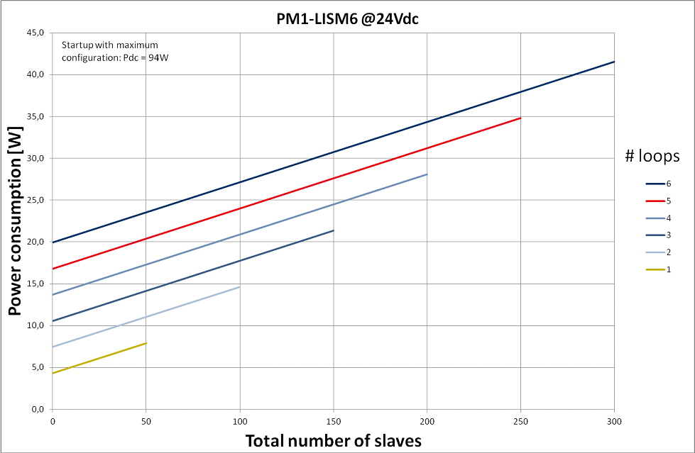

Battery power consumption 48 V

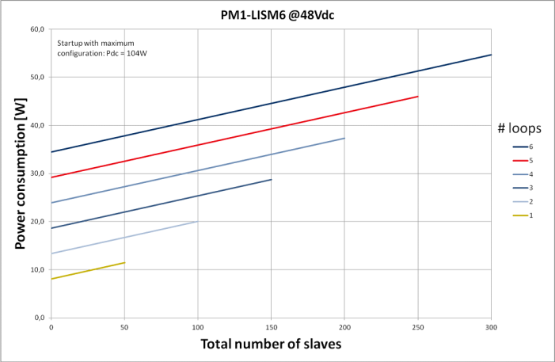

Mechanical

Dimensions (H x W x D)
For 19” rack use, with brackets | 88 x 483 x 400 mm  (3.5 x 19 x 15.7 in)
in front of brackets | 40 mm (1.6 in)
behind brackets | 360 mm (14.2 in)
Weight | 15.9 kg (35.05 lb)
Mounting | 19” rack
Color | Charcoal with silver

Environmental

Operating temperature | -5 ºC to +55 ºC  (+23 ºF to +131 ºF)
Storage temperature | -20 ºC to +70 ºC  (-4 ºF to +158 ºF)
Relative humidity | 15% to 90%
Air pressure | 600 to 1100 hPa

Isolator Board

Electrical

Loudspeaker loop connection | 120 VAC audio, max 5 A
Maximum loop though loudspeaker load | 500 W
Maximum tap-off load | 100 W
Test fault indicating LED | Yellow
Test button | Momentary

Mechanical

Dimensions (H x W x D) | 78 x 60 x 32 mm  (3.0 x 2.3 x 0.6 in)
Housing | 150 x 150 x 75 mm  (5.9 x 5.9 x 2.9 in)
Mounting options | - Ready mounted in the supplied housing  - Mounted inside the loudspeaker  - Mounted in an IP-65 housing (an optional mounting bracket LBB 4446/00 is required)
Weight | Approx. 180 g (6.3 ounces)
Color | Red
Fire-resistant properties | UL60065
Ingres protection | IP30
Punch out holes for cables | - 3 holes for 6 mm wires  - 3 holes for 9 mm wires

Environmental

Operating temperature | -5 ºC to +55 ºC  (+23 ºF to +131 ºF)
Storage temperature | -20 ºC to +70 ºC  (-4 ºF to +158 ºF)
Relative humidity | 15% to 90%
Air pressure | 600 to 1100 hPa

End-of-line resistor

Electrical

End of line resistor | 47 kohm, > 0.5 W resistor

DC Blocking Board

Electrical

Loudspeaker loop connection X1, X2 | 120 VAC audio, max 5 A
Maximum loop though loudspeaker load | 500 W
Tap-off X3 | 20 W on tap-off
High pass filter | - 67 Hz at 20 W load  - 34 Hz at 10 W load

Mechanical

Dimensions (H x W x D) | 60 x 45 x 30 mm  (2.7 x 1.8 x 0.6 in)
Mounting | Internally mounted in the loudspeaker (an optional mounting bracket LBB 4446/00 is required)
Weight | Approx. 16 g (0.6 ounces)

Environmental

Operating temperature | -5 ºC to +55 ºC  (+23 ºF to +131 ºF)
Storage temperature | -20 ºC to +70 ºC  (-4 ºF to +158 ºF)
Relative humidity | 15% to 90%
Air pressure | 600 to 1100 hPa

For more information please visit www.boschsecurity.com

© 2014 Bosch Security System BV
Data subject to change without notice
03-2014 V1.1

