Product Tests Report

Product name: DINION IP Thermal 8000
Model number and description:
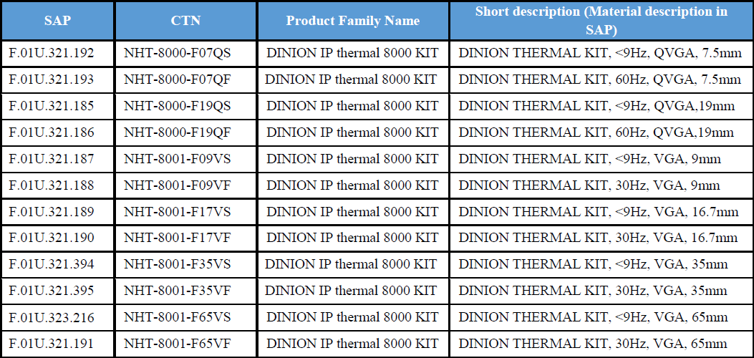
The above-mentioned Bosch Security Systems product has been tested in accordance and was found to comply with the tests listed below which were carried out during the development phase of the product. Please note that for some tests, test conditions exceed the range that Bosch recommends for effective continuous operation of the camera.
Data subject to change without notice.

ENVIRONMENTAL TEST
Directive or standard | Description | Passed
Dry heat Operational  IEC 60068-2-2:1974 +A1:1993+ A2:1994 | Temp. 70°C, duration 16 hours | Yes
Dry heat Storage  IEC 60068-2-2:1974 +A1:1993+ A2:1994 | Temp. +70 °C, duration 21 days | Yes
Cold operational  IEC 60068-2-1:1990 +A1:1993+ A2:1994 | Temp. -55 °C, duration 16 hours | Yes
Cold start test | For 24VAC test under -50degree, 4 hours can PASS normally. | Yes
Humidity, operational  Damp heat, steady state operational  IEC 60068-2-2:1988 | 55°C / 93 %RH, 25°C / 93% RH for 24 hours. Repeat for 6 cycle total. | Yes
IEC 60529 Ingress Protection Rating  Degrees of protection provided by enclosures (IP Code) [Dust, water ingress (operational)] | IPX6: protected against strong jets of water  IP6X: totally protected against dust | Yes
UL Type rating (similar to NEMA 4X) | 1.Hosedown test: 240L per minutes for 5 minutes  2.Additional corrosion test: 200 hours | Yes
Salt Mist  IEC60068-2-52 | 35 °C, 5% NaCl for 2 hours,  40 °C, 93%RH for 166 hours,  Total 4 cycles | Yes
External Mechanical Impact (IK Code)  IK10 Rating [“Vandalism-proof test”]  IEC 60068-2-75 | Energy 20J, 2 kg steel mass test slug,  50 mm striking radius, drop height 1 m  1 drop per position, impact 7 positions,  7 total impacts  Excludes window. | Yes
Vibration  IEC 60068-2-6:2007 | Freq. Range 10-150Hz, 10m/s², 3 axes, sweep rate 1 octave/min, 20 sweep cycles/axis | Yes
Shock operational  IEC 60068-2-27:1987 | Half Sine Impulse, 6ms, 40g | Yes
Solar  IEC 60068-2-5: 1975 | 1) Temperature:40 °C;  2) Radiation power :1120W/m2;  3) Test time: 240h | Yes
Wind load test | 1.Stability: 56mph for 1 minutes  2.Hold position: 74mph for 1 minutes  3.Robustness: 120mph for 10 minutes, 150mph for 10 minutes, repeat for 2 cycle | Yes
Transportation Tests (ISTA Procedure 2A) | 1.Atmospheric preconditioning:  23°C / 50%RH for 24 hours  2.Compression test: 2365N for 1 minutes  3.Vibration test: 60minutes, overall Grms level : 1.15  4. Drop test: 1 corner, 3 edges, 6 faces | Yes
NEMA TS2 – Sine wave vibration | Waveform: Sine Wave  Frequency Range: ( 5 ~ 30 ) Hz  Duration: 2.0 mm （2 ~ 13.2）Hz  Acceleration 0.5G  Sweep Type Logarithmic  Sweep Rate 0.5 Oct / min  Vibration Axial: X, Y, Z | Yes
NEMA TS-2- Shock | Waveform: Half Sine Wave  Acceleration: 0.5G  Duration: 15ms  Shock Axial: X, Y, Z  Single Axis Time: Each face took 3 times  Total Time: 18 times | Yes
ADDITIONAL ENVIRONMENTAL – FUNCTIONAL BOSCH TESTS
Environmental test methods | Specific Test Description | Passed
HALT (Highly Accelerated Life Test) | HALT LOL/UOL Temperature Test:  1 - Step temperature down from -20 °C by 10°C every 15 minutes (minimum) until operational failure and/or destruct failure.  2 - Step temperature up from +50 °C by 10 °C every 15 minutes (minimum) until operational failure and/or destruct failure.  HALT Vibration Test:  1 - The DUT is initially vibrated at acceleration level of 5g (rms) for minimum period of at least 15 minutes. After 15 minutes exposure, the DUT is tested operationally and results are recorded. The operating vibration level is then increased by 5g (rms) and the process is repeated for the next step in the test. This sequence is repeated until the DUT fails operational testing or the test level reaches 50g (rms). | Yes
Approvals Safety, EMC and Environmental
Specific Approval | Passed
EMC Europe according EMC directive 2004/108/EC | Passed
EN 55022:2010, +AC: 2011 (EN 55032, March-2017) | Yes
EN 50130-4:2011 | Yes
EN 50121-4:2006, +AC: 2008 | Yes
EN 55024: 2010 (EN 55035 in 2016) | Yes
EMC USA according FCC | Passed
CFR (Code of Federal Regulations)  Title 47: Telecommunications. Part 15 Radio Frequency Devices. Class B. 2012-10-1. | Yes
EMC Japan | Passed
VCCI Class B | Yes
Safety Europe according Low voltage directive 2006/95/EC | Passed
EN 60950-1: 2006, + A11: 2009, + A1: 2010, + A12: 2011, + A2: 2013 | Yes
Safety USA according UL Listing | Passed
UL 60950-1  UL 60950-22  CAN/CSA-C22.2 No. 60950-1-07  CSA 60950-22 (outdoor only)  *update version EN 62368, June-2019) | Yes

Environmental |  | Passed
Restriction of Hazardous Substances | ROHS complaint | Yes
Prohibited and declarable substances in products, components, materials and preparations. | Manufacturer’s declaration database based on N 2580-1 | Yes

The product is produced by a manufacturing organization which is certified on ISO9001 and ISO14001 standards.

